

Alpha Design Labs Cruise Portable Headphone Amplifier
24/96 USB Input and Analog Line input • 3.5mm Headphone Output
Mirror-Polished Stainless-Steel Chassis • Gorgeous Carbon Fiber Body • Elegant Appearance
Goes Anywhere • Rechargeable Battery • Superb Sound

Tokyo, Japan • Furutech Co., Ltd., manufacturer of analog and digital audio and video cable plus a wide range of accessories, debuts the ADL (Alpha Design Labs) Cruise Portable Headphone Amplifier. ADL creates quality products built to Furutech’s Pure Transmission standards at surprisingly affordable prices.

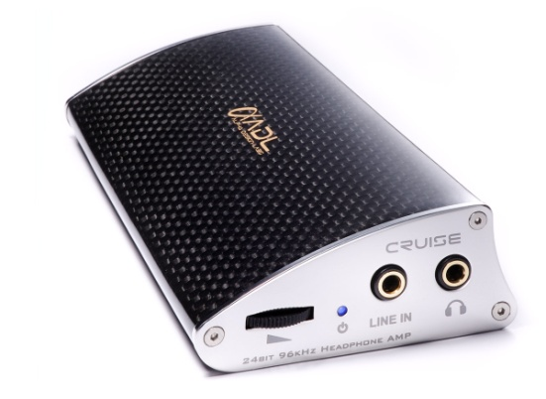
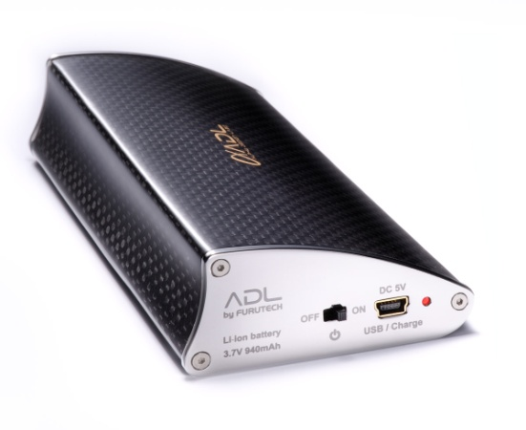
Lust in High Places
It’s the age of personal, portable electronics; everyone carries their music with them. Accessories reflect your personal style and the Cruise is sure to create jealousy and envy wherever you go. It delivers thrilling sound to match its gorgeous appearance. Whether you’re using iTunes for low-bit-rate downloads or high resolution music files just connect your computer to the Cruise with one of our matching ADL Formula 2 USB cables or the new i-D35SP analog stereo cables. When you’re on the road plug your music player’s analog headphone output into the line input of the Cruise and open the player’s volume to maximum and use the volume control on the Cruise. For higher resolution all-digital signals simply connect the Cruise to your computer’s USB port. The USB port charges the battery and you can listen to music while it’s charging!

Features
- Mega performance, Furutech takes what’s there and makes it better!
- Beautifully finished, lustrous carbon fiber and mirror-polish nonmagnetic stainless steel body
- Fits in the palm of your hand, enjoy your music anywhere
- High quality volume control (front) and On/Off switch (rear)
- Gold-plated 3.5mm analog line input (switched) or gold-plated USB digital input for PC audio (Phone jack overrides output from USB mini-B interface on rear panel)
- Runs on USB power or an AC/DC switching power adapter that recharges battery
- High performance headphone amplifier drives 12 to 600 ohm headphones
- Gold-plated circuitry on high quality printed circuit board

Front Controls and Indicators:
a. HEADPHONES OUTPUT: 3.5mm phone jack
b. LINE INPUT: 3.5mm switched phone jack
c. VOLUME: Rotary-type variable resistor
d. One dual RED and BLUE LED: BLUE indicates Power On / RED indicates Battery Low

Rear Panel:
a. MASTER POWER ON/OFF
b. USB: 1 USB mini-B Type
c. Internal DC3.7V, 940mAh Li-ion Type 14650 Rechargeable Battery
d. Charging Indicators: One dual-color RED and GREEN LED: RED indicates Charging / GREEN indicates Full Charge

Specifications
Output Jack: 3.5mm Phone Jack x 1 | Headphone Output Level (Max.): 1%THD 1kHz  78mW (12 ohm) 94mW (16 ohm) 110mW (32 ohm) 98.6mW (56 ohm) 23mW (300 ohm) 16mW (600 ohm)  Frequency Response:  Line in: 20Hz~20kHz (±0.5dB) headphone output USB in: 20Hz~20kHz (±0.5dB) headphone output  Channel Separation: 60dB (1KHz)  Total Harmonic Distortion: 0.02% (Line Input 1KHz)
Input Jack: Line In (3.5mm Switched Phone Jack) x 1, USB In (mini B type) x 1
Signal to Noise Ratio :
Line in: 100dB (A-Weighted)
USB in: 96dB (A-Weighted)
DAC Chip: WM8716 192kHz/24bit
USB Chip: TE7022L 96kHz/24bit
Power Supply-1: DC5V , 2000mA , 10W Switching Power Adapter | Music Playback Time: Up to 80 hours when fully charged (5 hours charge time approx.)
Power Supply-2: DC3.7V, 940mAh Li-ion Type 14650 Rechargeable Battery | Dimensions: 65.5mm/2.5” (W) x 120mm/4.7” (D) x 28.3mm/1” (H) mm and Weight: 198g/7-ounces
About Alpha Design Labs
Furutech is justifiably proud of its reputation for engineering, build quality and performance. ADL was created by Furutech to imbue its Pure Transmission Technology into carefully engineered innovative designs that everyone can afford for creating high-level computer-based sound. ADL components are made with the same dedication to total resonance control and refinement as all of Furutech’s many cables and accessories.

ADL product enquiries email: service@adl-av.com
Furutech Co., Ltd. Tokyo Japan
www.adl-av.com

