

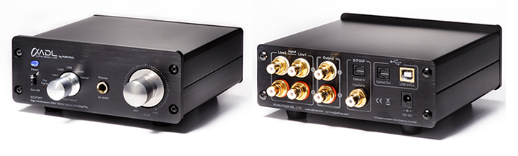

Alpha Design Labs Esprit DAC and Digital Preamplifier
24/192 DAC and ADC • 24/96 USB • Low Jitter Clock Recovery System
A Compact, Surprisingly Cost-Effective Gem to Control Your Multimedia Audio System

Tokyo, Japan • Furutech Co., Ltd., manufacturer of analog and digital audio and video cable plus a wide range of accessories, debuts the ADL (Alpha Design Labs) Esprit DAC and Digital Preamplifier. ADL creates quality products built to Furutech’s Pure Transmission standards at surprisingly affordable prices.

As the great jazz composer Sun Ra says, “Space is the place,” and audio enthusiasts all over the globe know that to be true. Most of us live in tight quarters and there’s little room for large, energy-depleting components. Plus a growing number of enthusiasts are using their computers to store and play music. But audiophiles and music lovers still want what they want, better sound and more convenience.

Last year Furutech introduced the popular ADL GT40 USB DAC/Analog Recorder. It’s the analog cousin of the higher specified Esprit, a compact USB DAC/Preamplifier with digital as well as analog inputs. Completely control an analog, digital or computer-based system with superior sound while recording vinyl or any other analog or digital source to hard disk! The exceptional headphone amplifier drives 32 to 600 ohm ‘phones with aplomb.
The Esprit is designed around a high-performance 24-bit/192kHz Wolfson WM8716 DAC. ADC duties are covered by the Asahi Kasei AK5385B 24-bit/192kHz converter with Enhanced Dual Bit Architecture that delivers a stunning 114dB dynamic range. The Esprit features optical, coaxial and a pair of line-level inputs for all your home entertainment devices. It also carries both analog and optical outputs (optical for USB sources only).
The sound is vivid, captivating, palpable and unheard of in this price category. The ADL Esprit brings Furutech’s signature smooth, detailed clarity to high-resolution 24-bit/96kHz files and even 16-bit/44.1kHz files sound better and more satisfying!
Features
- 24-bit/192kHz Wolfson WM8716 DAC
- 24-bit/192kHz Asahi Kasei AK5385B ADC
- 24-bit/96kHz Tenor TE7022L Hi-Q USB Audio Streaming Controller supports ASIO
- Self-installing driver
- External power supply
- Headphone Amplifier: TI TPA6120A driving from 32 to 600 ohms at >120dB dynamic range
- Highest Quality Parts like ELNA ROB capacitors
- Line-In and Line-Out OPA: OPA2134 (IC Sockets )
- High-performance Furutech gold-plated PTFE-insulated RCA connectors with best-quality aluminum chassis and beautifully-machined volume control

Specifications
USB & Analog Playback and Records Multimedia
Connectivity: USB B Interface, analog input/output on RCA jacks,
Optical input/output Toslink jacks, Coaxial input RCA jack
USB Playback Resolution: 24-bit/96kHz(max)
USB Recording Resolution:
Resolution : 16 to 24-bit supported
Sampling: 8 /16 /32 /44.1 /48 /96 kHz sampling rates supported
192kHz/24-bit DAC and ADC
Frequency response: 20Hz ~ 20kHz (±0.5 dB)
S/N ratio: -95dB (A-wtd) / Line Output
Max. Line Output Level: 7.5 Vrms (THD<1%)
THD: Line Input < 0.01% , Digital Input <0.05%
Headphone Max. Output Level: 200mW/32 ohm s ( THD<1% )
Power Supply AC Adaptor Rating:
Erp Step2 Compliant, 2-Wire AC input, Class II, AC/DC Switching Adaptor output DC 15V / 0.8A / 12W
Dimensions: 150 (W) x 141 (D) x 57 (H) mm
Weight: 900g Approx. / 2lbs

ADL product enquiries email: service@adl-av.com
Furutech Co., Ltd. Tokyo Japan
www.adl-av.com

