
Alpha Design Labs ADL H118 Headphones
Discover Your Inner Sound

ADL – Alpha Design Labs – creates innovative, smart-looking components with scintillating sound for computer-based systems as well as personal and portable electronics. Tokyo-based ADL by Furutech™ aims high using the best materials and innovative design for an expanding line of Japanese designed precision products that include the superb sounding and superbly comfortable H118 Headphones.
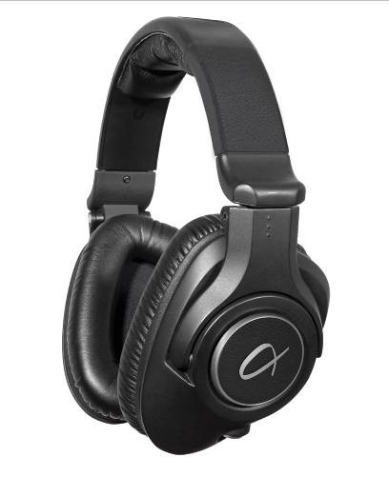
It’s All in Your Head…
What could possibly be more intimate than listening to music through headphones? ADL engineers are currently working on an answer to that but so far no word! It’s just you and the sound in your head.

Headphones are in intimate sonic and physical contact with the listener and reveal problems in the audio chain or the headphones themselves! Too many headphones have too much bass, or they’re too bright with a thick, congealed midrange, most are uncomfortable to wear and ultimately fatiguing.

Alpha Triform Contour Earcups™
Triform Earcups are specially designed for a superior seal over your ears improving bass response over other designs. The Triform Contour also reduces internal standing waves and reflections for reduced distortion. The headband flare over the Alpha Triform Contour Earcups make the H118 Headphones supremely comfortable, an observation everyone makes before suddenly captured by the sound and falling silent! The ADL H118 is balanced in a completely audiophile way, a very Furutech way. Rich tonal colors and textures with intimate and close harmonic interplay, a sense of space and quiet backgrounds are the key. It’s an involving emotional experience when you’re THIS CLOSE to the music.

Furutech Pure Transmission technical tidbits abound; high noise attenuation, 40mm high-resolution extra-large high-flux α (Alpha) Cryo-treated magnet drivers, a ring engineered to keep ultra-high frequencies in coherent phase and excellent transient response from extremely light-weight coils made with copper-coated special aluminum alloy wire.

Pair H118s with Alpha Design Labs Esprit and GT40 USB DAC/Preamplifiers or the Stride and Cruise Portable Headphone Amplifiers, or any other quality headphone playback system plus an iHP-35 series ADL cable and become intimate with your music.

Features
- Dynamic closed-back circumaural headphones
- High noise attenuation and low distortion tailor-made diaphragms
- 40mm extra-large high-flux α (Alpha) Cryo-treated magnet
- Ring between voice-coil and diaphragm keeps ultra-high-frequencies in phase
- Excellent transient response from extremely light-weight coils of copper-coated special aluminum alloy wire
- Furutech nonmagnetic rhodium-plated stereo α (Alpha) to mini-XLR socket
- Included in package
3.0 meter cable and gold-plated 1/8” (3.5mm) to 1/4” (6.3mm) adapter

Specifications
Acoustic Design: Dynamic closed-back
Driver: 40mm diameter special high-flux magnet
Sensitivity : 98dB SPL (1mW) at 1 KHz
Frequency response: 20Hz ~ 20kHz
Input Power: 200mW (Max.)
Rated Impedance: 68 ohm @ 1KHz
Ear pad: Leatherette
Head Band Pressure: 4.5 N Approx.
Connector: Nonmagnetic rhodium-plated stereo α (Alpha) mini-XLR socket
Weight: 245g (8.64oz) Approx. (without cable) 310g (10.93oz) Approx. (with cable)

Assembly
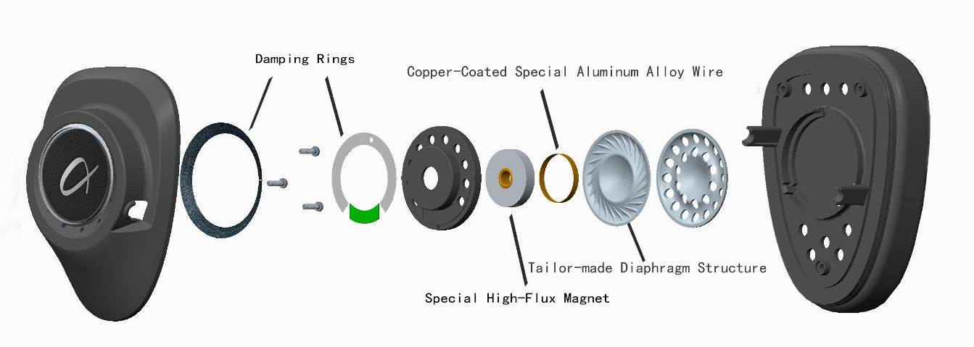

ADL product enquiries email: service@adl-av.com
Furutech Co., Ltd. Tokyo Japan
www.adl-av.com

