

Furutech’s DeMag Frees LPs, Optical Disc Media, Cables and Connectors of Magnetically-Induced Distortion
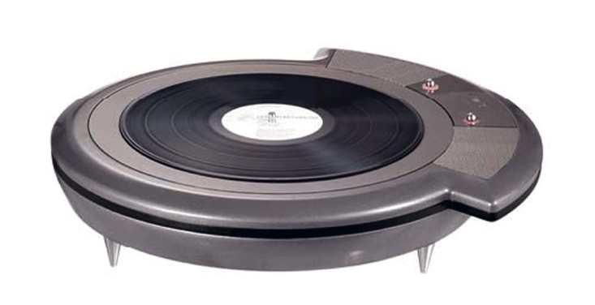
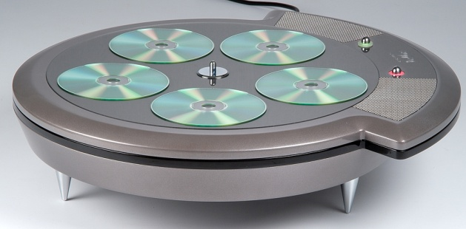

Furutech Co., Ltd., manufacturer of analog, digital, audio and video cable and accessories, presents their CEA Innovations Award-Winning DeMag Demagnetizer. It completely demagnetizes LPs and optical disc media like CD, CD-R, DVD, MD, Game CD, Photo CD, SACD, and DVD-Audio. Plus the DeMag an indispensable accessory for keeping interconnects, power cords and their connectors completely demagnetized preventing distortion.

Disc Magnetization Is No Mystery
The silk-screened label on an optical disc contains chemical compounds such as iron, nickel, and cobalt. These materials are strongly magnetic and easily remagnetized. The reflective information-bearing surface of optical media contains 99% aluminum, but 1% of these same highly magnetic materials! Even aluminum is considered a weak magnetic conductor.

Amazingly, optical discs actually magnetize as they play! A magnetic field is induced as they spin. This same elemental process takes place with CD, CD-R, DVD, and MD. Particular attention is due MD as it’s most prone to magnetization effects such as problems reading discs.

Other so-called demagnetizers on the market including specialist products, head erasers, bulk erasers, etc. don’t even completely demagnetize your discs. Rather, some of them actually induce magnetic fields! Take spinning demagnetizers, for example. After the disc stops, a section of the CD is left exposed to the fixed magnet below. Because Furutech’s deMag Ring Magnet Technology ramps power up then down again, all residual magnetism is completely removed.

The deMag works for disc media as well as LPs, cables, connectors, and power cords! (See below.) Furutech’s Pure Transmission technology guarantees no part of the playback chain is contaminated by resolution-sapping magnetic interference.

The graphs below demonstrate that untreated magnetic fields actually effect data retrieval. These errors are easily demonstrated with today’s high resolution systems. Look for coarse video distortion and listen for grainy, unmusical, bright and forward sound.

Of course, magnetism is a naturally occurring process, so it can be said looking at the data below that, in fact, it’s virtually impossible to achieve a clean, precise signal without going through a properly designed demagnetization process.

Demagnetization was a mainstream process routinely performed by disc manufacturers all over the world. Because of the tight, ultra-competitive market, most manufacturers skip this important step these days. Top performance can only be achieved by demagnetizing all discs before recording.

Demagnetizing LPs
Pigment added to the plastic during the manufacturing process is the magnetic culprit. The minute amount of ferrous material in the coloring causes magnetization. Testing at the Tokyo Nanotechnology center with a IHI Gauss meter showed that after an LP was treated with the deMag the magnetic field of the LP was lowered from 620~630 nT to 572~582 nT (nanotesla: a unit of magnetic field strength,1 Tesla = 10,000 gauss – see below).
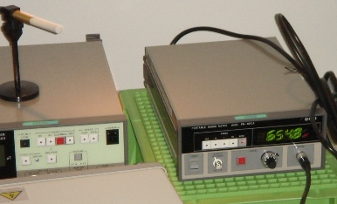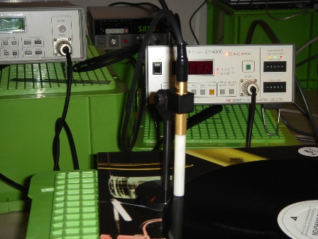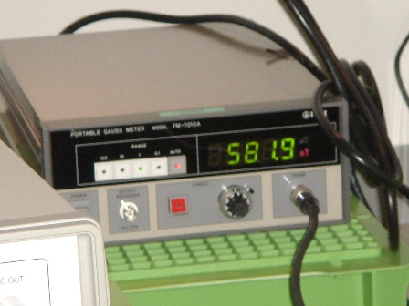

Vinyl is also in pressurized contact with ferrous materials during the LP manufacturing process. Records are made by heating plastic granules in a large steel mixer. As temperatures rise miniscule particles of steel wind up in the vinyl mix. Then it goes through a high pressure roller press that’s typically made from heavily ferrous materials. Finally, the vinyl is ready for its final transformation into a finished LP, and that’s done with a super-ferrous nickel stamping master! And the nickel is often electroplated with yet other ferrous metals such as chromium. And of course these masters require regular replating as they wear out, and that winds up embedded in the vinyl as well.

Hand-Wound and 7 Miles Long!
One of the key elements behind the universal praise, not to mention the unit’s size and price, is its high performance hand-wound copper wire field-generating coil. It’s a full 7 miles long (!) and projects a powerful magnetic field achieving a uniformity of effectiveness across the entire surface of the LP.

Furutech theorizes that in magnetic terms both LPs and optical media are varyingly magnetized across their surface at different potentials as well, and proposes that a powerfully-thrown field that ramps up, holds, then ramps down demagnetizes the entire surface to zero potential.

LP Magnetic Noise Interference
Now we know what 7 miles of wire can do, how does it affect just a few ultra-sensitive turns of coil in a moving coil cartridge? How does the careful listener hear the difference between magnetized and non-magnetized LPs in the listening room?

We begin with moving-coils’ low output of 0.5mV ~ 0.8 mV making them more susceptible to magnetic interference than higher-output moving magnet cartridges. But they’re both extremely sensitive to field disturbances from 20Hz out to 100kHz. That’s why most cartridge makers go to great lengths to reduce magnetic modulation noise within the cartridge using special non-ferrous materials for improved transmission of low level information. As most audiophile music lovers know, reducing the noise floor enhances refinement and resolution, dynamics, the soundstage and a sense of spaciousness.

A cartridge’s exposed, unshielded, sensitive assembly rides in extremely close proximity to the theorized surface magnetization and proven random static charges on an LP’s surface. That’s why you hear the improvement after deMag treatment, the sound free of all the accumulated micro-noise in the LP playback chain.

Demagnetizing Cables
Electric current generates a magnetic field as it flows through a power cord or conductor. However, magnetic impurities within the materials themselves become magnetized and introduce further magnetic distortion. Just loop your cables and power cords on the top surface of the DeMag and begin treatment. There are no other demagnetizers on the market that are so versatile and effective. The DeMag can even be used on metal-based accessories like CD stabilizers and speaker terminals.

The Sound
Demagnetizing both sides of optical media before play results in a greater sense of power, dynamics, and resolution, with cleaner, blacker backgrounds and a larger, more stable soundstage, vivid tonal colors and deeper extension at both ends of the frequency range. Demagnetization also communicates the delicacy, refinement and nuance of a performance, along with the micro- and macro-dynamics needed to realize the full potential of music and movies.

Using the DeMag improves the sense of surround sound involvement in every two-channel and multichannel home theater system. Visceral, exciting sound heightens the emotional and participatory sense of music and especially home theater.

The Image
Since the DeMag eliminates all magnetic distortion noise, video displays of all types benefit from less ghosting, color shift, “snow”, vertical and horizontal interference lines. After treatment you’ll notice a higher resolution picture with more finely graded contrast, clean and precise, with bright, saturated colors and a more sophisticated color pallet.

The Science
Examining (fig.1 and fig.3) in the graphs below, the untreated output clearly shows multiple peaks at other than the 1kHz test tone. These peaks represent noise and distortion caused by magnetic field interference. The amplitude and fast rise-time of these sidebands indicate a negative impact on audio and video resolution. Looking more closely, white or blank areas can be seen in the 1kHz sidebands. Furutech engineers believe these are caused by read errors. You can also see small peaks between 200 to 800Hz that represent noise and distortion products.

Fig.1 Untreated | Fig.2 Treated | Fig.3 Untreated | Fig.4 Treated
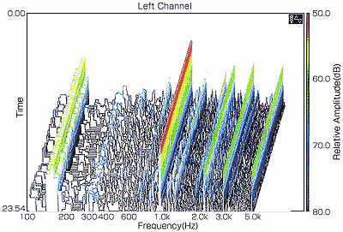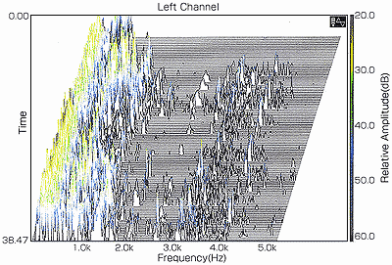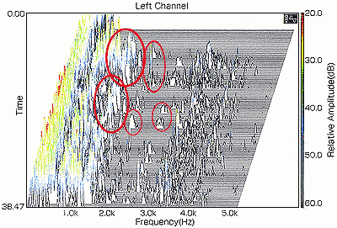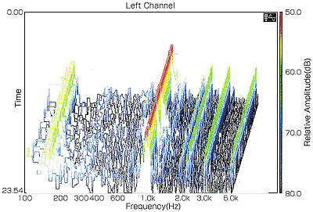

After demagnetization, the excessive peaks in the 1kHz sidebands disappear, as do the blank read problem areas. The peaks become more uniform in height and chaotic interference patterns seen before demagnetization are almost gone. The peaks of other sideband components are more uniform and the range between 200 to 800Hz is cleaner. These graphs clearly show that the S/N ratio is much improved after demagnetization, while audible distortion is lowered.

Note the highlighted areas in fig.4 at about 20 seconds between 1kHz and 5kHz. You can see the number of peaks increase, meaning there’s more information as a result of demagnetization. The peaks’ height also generally increase with the same result—more information.

CD Test Data
Recording Time 4:45

 | Output Power Level  PWL dB | Total Harmonic Distortion % THD | Signal-to-Noise Ratio  % SNR
No YUMI | -13.36 | 72.11 | 2.047
UC YUMI | -13.36 | 71.75 | 2.117
RD YUMI | -13.94 | 70.99 | 1.866

No YUMI: Music CD prior to demagnetization
UC YUMI: Results of treatment with another brand of CD demagnetizer
RD YUMI: Results of treatment with Furutech’s deMag

Note that RD YUMI -- the DeMag treated measurements -- has the lowest output power level (PWL). Interestingly the peak level analyzer shows more peak activity as the noise floor drops post-demagnetization. DeMag treatment also makes for the lowest THD; evidently demagnetization lowers distortion as well.

Looking at UC YUMI using another brand of demagnetizer we see the signal-to-noise ratio actually increases after treatment! The other device under test doesn’t ramp up, hold, then ramp down its power like the DeMag. Our analysis reveals this device doesn’t, in fact, demagnetize anything, but simply lines up an existing magnetic field. That’s why the SNR increases after treatment.

CD-ROM Test
Notice the Read value is 590KB/s with 65 points total prior to demagnetization, and 620KB/s with 69 points after demagnetization. The rising rate seems to indicate the DeMag improves the read performance of CD-ROMs.

There are times when a CD-ROM or RAM disc either cannot be read or recorded to. It may be caused by damage to the information-bearing substrate of the disc. Or it could just be magnetized! Try it… those discs may play again.

 | READ KB/s | Total
Before | 590 | 65
After | 620 | 69

The above measurements were made with a Marantz CD-16SE Player and NEC PC-98 Xa7 Computer running Spectral Lab’s Soft-Sound.

Furutech’s DeMag holds the following Patent Numbers:
Japan #2942760 U.S. #6058078

Specification:
Dimensions: 487mm/19” W × 68mm/2.7” H (without spikes) × 470mm/18.5” D
Net Weight: 11.0Kgs/24lbs
Rating: 110VAC ±15V

About Furutech
Furutech makes a wide variety of high performance 15A and 20A A/V cable and power connectors and parts, as well as distribution/filtering products including the 120Hz standard xv1.3 HDMI cable, GT2 USB 2.0 and GT3 USB 3.0 cables, Ag-12 Silver Tonearm Cable, The Silver Arrows Tonearm Cable, La Source Headshell Wires, Monza LP Stabilizer Weight, the new Lineflux and Evolution II series, Pure Power 6, e-TP4+4, e-TP609, e-TP615 and e-TP60 Power Distributors, and e-TP80 Power Filters, deMag Disc and Cable Demagnetizer, PC-2 Disc Pure Cleaner, and their own very special NANO Liquid Contact Enhancer, plus even more fine cable and OEM products.

Awards
DeMag Wins CES Best of Innovations ’07 • e-TP609 Wins Absolute Sound Product of the Year Awards ’07 • G-320A-18 Power Cord Wins 6moons Blue Moon Award ’07 • Evolution Cables Wins Best of 2007 Awards Enjoy the Music • Reference III Cables Win Absolute Sound Editors’ Choice ‘07/’08 • AG-12 Phono Cable Wins the SoundStage Network’s Reviewers’ Choice Award ’08 • Ag-12 Phono Cable is Tone Audio’s Exceptional Value Award ’08 • Monza LP Stabilizer, Silver Arrows Phono Cable, La Source Headshell Extensions All Win Tone Audio’s Accessory Products of the Year • xv1.3 HDMI Cable Wins Positive Feedback’s Brutus Award ’08 • FI-50 Piezo Ceramic Series Connectors Win CES Best of Innovations ’09 • Monza LP Stabilizer Wins Positive Feedback’s Brutus Award ’09 • Select Series Fuses Win Positive Feedback’s Brutus Award ’09 • GT2 USB Cable is Playback Recommended ’09 • Torque Guard Speaker Binding Posts Innovations Honoree ’11.

FURUTECH CO., LTD. • service@furutech.com

Press • Info • Review • Images
Scull Communications • 212.807.0519
jscull@scullcommunications.com • www.scullcommunications.com
www.scullcommunications.com/pressresources.html

