

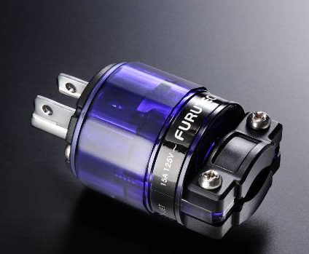
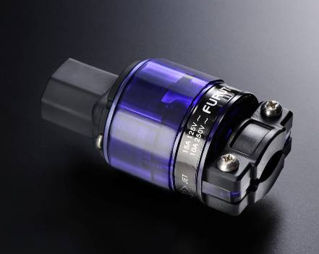

New at CES for 2011
FI-11M(R) and FI-11(R) Rhodium-Plated
High Performance AC Connectors

Tokyo, Japan • January 1st, 2010 • Furutech Co., Ltd., manufacturer of analog and digital audio and video cable plus a wide range of accessories, debuts the FI-11M(R) and FI-11(R) High Performance AC Connectors. (

It’s More Than Just the Conductor
Like and orchestra, every element must play well for a first-class result. The first thing everyone thinks about power cables is the conductor, geometry and shielding. The materials and build quality of the connectors at either end are also key elements in maintaining undistorted signals. Furutech lavishes meticulous attention to build quality, a large part of the Pure Transmission engineering equation: Top quality α (Alpha) pure copper conductors feature a stainless cable damping clamp with stainless screws in an attractive nylon/fiberglass body and polycarbonate shell. Start with the best!

FI-11M(R) Specifications:
- α (Alpha) pure copper conductors
- Floating Field Damper System* avoids induced magnetic field effects
- Nylon/fiberglass front body, polycarbonate shell (transparent blue)
- Specified for cable diameters of 6.6mm to 16.0mm (with a longer screw up to 20mm)
- Stainless cable damping clamp with stainless screws (M4 x 20mm L)
- Dimensions: Body length 40.0mm x 39.0mm dia. x 73.0mm overall length

Both Feature Specially Engineered Pressure Plate and Wire Clamp

FI-11(R) Specifications:
- α (Alpha) phosphor bronze conductor
- Floating Field Damper System* avoids induced magnetic field effects
- Nylon /fiberglass front body, polycarbonate shell (transparent Blue) shell
- Specified for cable diameters of 6.6mm to 16.0mm (with a longer screw up to 20mm)
- Stainless cable damping clamp with stainless screws (M4 x 20mm L)
- Dimensions: Body length 44.0mm x 39.0mm dia. x 77.0mm overall length

Floating Magnetic Field Effects
Current flowing through a cable and its connector creates magnetic (and electrostatic) fields around them, building and collapsing 60 times per second in 120VAC systems. This magnetic field induces current flow–electrical potential–in small parts like the screws holding the connector shell together which have to be metal for tight clamping. The current flow in these small parts actually creates “floating” magnetic fields around them, and they interfere with the cable/connector’s larger surrounding magnetic field resulting in noise and distortion.

The Furutech Floating Field Damper solves the biggest problem you never realized you had by star grounding the metal parts in which floating magnetic fields are induced by current flow. A precisely engineered sprung metal bridge in the connector body ties the various metal parts together and shunts whatever electrical potentials that are generated to ground. This significantly lowers noise by reducing distortion for ultra-clean and stable power transfer.

About Furutech
Furutech makes a wide variety of high performance 15A and 20A A/V cable and power connectors and parts, as well as distribution/filtering products including the 120Hz standard xv1.3 HDMI cable, GT2 USB 2.0 and GT3 USB 3.0 cables, Ag-12 Silver Tonearm Cable, The Silver Arrows Tonearm Cable, La Source Headshell Wires, Monza LP Stabilizer Weight, the new Lineflux and Evolution II series, Pure Power 6, e-TP4+4, e-TP609, e-TP615 and e-TP60 Power Distributors, and e-TP80 Power Filters, deMag Disc and Cable Demagnetizer, PC-2 Disc Pure Cleaner, and their own very special NANO Liquid Contact Enhancer, plus even more fine cable and OEM products.

Awards
DeMag Wins CES Best of Innovations ’07 • e-TP609 Wins Absolute Sound Product of the Year Awards ’07 • G-302A-18 Power Cord Wins 6moons Blue Moon Award ’07 • Evolution Cables Wins Best of 2007 Awards Enjoy the Music • Reference III Cables Win Absolute Sound Editors’ Choice ‘07/’08 • AG-12 Phono Cable Wins the SoundStage Network’s Reviewers’ Choice Award ’08 • Ag-12 Phono Cable is Tone Audio’s Exceptional Value Award ’08 • Monza LP Stabilizer, Silver Arrows Phono Cable, La Source Headshell Extensions All Win Tone Audio’s Accessory Products of the Year • xv1.3 HDMI Cable Wins Positive Feedback’s Brutus Award ’08 • FI-50 Piezo Ceramic Series Connectors Win CES Best of Innovations ’09 • Monza LP Stabilizer Wins Positive Feedback’s Brutus Award ’09 • Select Series Fuses Win Positive Feedback’s Brutus Award ’09 • GT2 USB Cable is Playback Recommended ’09 • Torque Guard Speaker Binding Posts Innovations Honoree ‘10

All Metal Parts Treated with Furutech’s α (Alpha) Super Cryogenic and Demagnetizing Process
Make A More Powerful Connection with Furutech!
FURUTECH CO., LTD. • service@furutech.com

Press • Info • Review • Images • Scull Communications • 212.807.0519
jscull@scullcommunications.com • www.scullcommunications.com www.scullcommunications.com/pressresources.html

