

Now Shipping! Furutech FireBird IEEE 1394 FireWire Cable
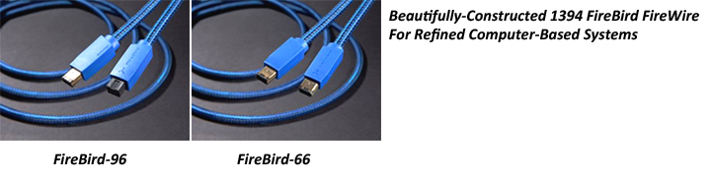

July 16th, 2012 • Tokyo, Japan • Furutech Co., Ltd., manufacturer of analog and digital audio and video cable plus a wide range of accessories, is now shipping the luxurious FireBird IEEC 1394 FireWire cable line in 9-to-9 and 6-to-6 pin configuration.

When it comes to cables everything makes a difference; materials, geometry, treatments, insulation and shielding all affect the sound and picture. You want high full-band transfer rates, solid construction and reliability… if the cable doesn’t look like an eye-sore so much the better! The FireBird series dazzles with its looks and specs; 24 AWG silver-plated α (Alpha) OCC conductors and 20 AWG silver-plated α (Alpha) OFC power conductors for one powerful connection!

Digital music files take up a lot of space and external hard drives are a must. FireWire drives enable smoother USB output to an external DAC. Furutech is known the world over for quality and a wide variety of cables and accessories. They deliver consistently superb results because Furutech engineers adhere to Pure Transmission techniques; examine every element of signal and power transfer and optimize it all. Furutech’s beautifully finished products match the sheer beauty of the sound and video, the result of meticulous engineering and artful construction.

Features
- High-performance IEEC 1394 FireWire cable transfers up to 800 Mbps (FireBird-99)
- Main conductor: 24 AWG silver-plated α (Alpha) OCC
- Power conductor: 20 AWG silver-plated α (Alpha) OFC
- FireWire Connectors: 9-pin-to-6-pin / 6-pin-to-6-pin
- Low-noise double-layer isolation with aluminum-foil and copper-wire braiding
- Triple shielded
- Jacket: RoHS-compliant flexible PVC and Nylon braided sleeve
- Production Lengths: 0.6m / 1.2m / 1.8m / 3.6m / 4.5m

Construction and Materials
- Main conductor: 7/0.2 silver-plated α (Alpha) OCC (24 AWG)
- Insulation: Nitrogen-injected skin-foam-skin PE, Blue / Orange / Red / Green
- Power Conductor: 26/0.16 silver-plated α (Alpha) OFC (20 AWG)
- Insulation: Nitrogen-injected skin-foam-skin PE, Red / White
- Ground: 7/0.127 α (Alpha) tinned copper wire (28 AWG)
- Shield 1 and 2: AL / Mylar film
- Shield 3: α (Alpha) tinned copper wire braid
- Jacket: RoHS-compliant flexible PVC (Black)
- Sleeve: Nylon braid, OD: 7.6mm
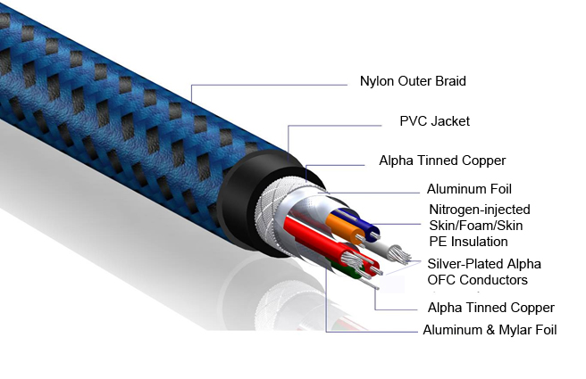

Awards
DeMag Wins CES Best of Innovations ’07 • e-TP609 Wins Absolute Sound Product of the Year Awards ’07 • G-320A-18 Power Cord Wins 6moons Blue Moon Award ’07 • Evolution Cables Wins Best of 2007 Awards Enjoy the Music • Reference III Cables Win Absolute Sound Editors’ Choice ‘07/’08 • AG-12 Phono Cable Wins the SoundStage Network’s Reviewers’ Choice Award ’08 • Ag-12 Phono Cable is Tone Audio’s Exceptional Value Award ’08 • Monza LP Stabilizer, Silver Arrows Phono Cable, La Source Headshell Extensions All Win Tone Audio’s Accessory Products of the Year • xv1.3 HDMI Cable Wins Positive Feedback’s Brutus Award ’08 • FI-50 Piezo Ceramic Series Connectors Win CES Best of Innovations ’09 • Monza LP Stabilizer Wins Positive Feedback’s Brutus Award ’09 • Select Series Fuses Win Positive Feedback’s Brutus Award ’09 • GT2 USB Cable is Playback Recommended ’09 • Torque Guard Speaker Binding Posts Innovations Honoree ’11 • ADL GT40 Wins Tone Audio’s Budget Digital Product of the Year Award ’11 • ADL GT40 Wins SoundStage Network’s Good Sound Great Buy Award ’11 • PFO Writers’ Choice Award for the Furutech deStat II, GT40, Flow28, and the DeStat II ’11

FURUTECH CO., LTD. service@furutech.com

Make A More Powerful Connection With Furutech!

