

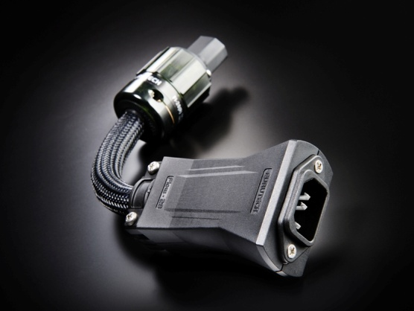

The Furutech Flow-28 Inline Power Filter
New for 2011!

AC Power Can Make or Break Your System!
The audio you hear from your home entertainment system is essentially the incoming electricity itself, and the typically violent storms riding the AC line and its ground is very detrimental to the performance of your components.

The Flow-28 is a sophisticated, luxuriously made and finished inline power filtering unit that eliminates many common problems caused by contaminated electrical power lines. It protects against distortion caused by ground noise, voltage spikes and sags, high frequency power supply noise from other components in your own system, and finally high-frequency digital noise emanating from processors and digital interconnects.

Plus you’re never alone when you take your listening seat; the residential AC supply is shared with other apartments, homes, and businesses on the same utility transformer explaining why many enthusiasts find their systems perform to a higher standard late at night and over weekends.

And while the Flow-28 is a star performer at eliminating common AC problems, it does it all without restricting current draw in any way. Furutech, known for its world-class Pure Transmission engineering, build and finish, have done the tests and the Flow-28 does not interfere with current draw. The AC-1501R EMI-filtering IEC input perfectly complements the remarkably effective Flow-28’s ability to eliminate distortion. The FI-28R IEC connector finishes off the package.

The Flow-28 Inline AC Filter lowers noise on every component on which it’s used resulting in very natural and extremely fine resolution down and through the utterly silent noise floor. It improves soundstaging and imaging while creating nuanced high frequencies, an attractive, engaging midrange, tight and controlled bass, with power and dynamics to spare.

Amazing Features

- The body of the Flow-28 combines two “active” materials: Nano-sized ceramic particles and powdered carbon plus Nylon and fiberglass to form an extremely effective mechanically and electrically damped body
- Use between power cables and power distributors or power cables and components
- Eliminates radiated AC noise
- Fitted with rhodium-plated α (Alpha) nonmagnetic FI-28R connector
- AC-1501R EMI-filtering IEC features rhodium-plated α (Alpha) nonmagnetic copper alloy conductors plus…
- A parallel circuit with an in-line coil and capacitor that reduces noise at 1MHz by 10dB and at 10MHz by more than 30dB
- Floating Field Damper™ (Earth/Ground Jumper System) with US Patent No.: 6,669,491
- Patent-pending metal cable clamp improves grip and reduces mechanically and electrically induced distortion
- α (Alpha) conductor shield for protection against radiated noise
- RoHS-compliant flexible PVC sheath improves vibration isolation
- Special high-grade PE Insulation contributes to reduced capacitance
- Incorporating Furutech’s special passive GC-303 EMI filtering material

The AC-1501R EMI Filtering IEC Input
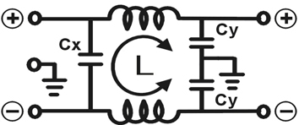

L: 0.2mH • Cx: 0.1uF • Cy: 2200pF x 2

- Rhodium plated α (Alpha) nonmagnetic copper alloy conductors
- Outer cover • Chrome-plated steel-plate
- Inner cover • Nylon fiberglass
- Inner Box • Nylon fiberglass
- Inner parts held in place with Piezo Epoxy
- Rating • AC 115V/250V 15A 50/60Hz

Cable Specifications
- Conductors • 56-strand (Inner) and 29-strand (outer) α (Alpha) OCC .175mm x 3 cores
- Insulation-1• Irradiated PE (Red/Natural/Yellow) 3.45mm diameter
- Insulation-2 •Irradiated PE surrounded by Teflon tape wrap, 3.6mm diameter
- Inner Sheath • RoHS-compliant flexible PVC incorporating carbon particles
- Shield • 0.12mm diameter α (Alpha) Conductor wire braid
- Sheath • RoHS-compliant flexible PVC, 14.2mm diameter
- Jacket • Vibration-damping Nylon yarn braid (Black)
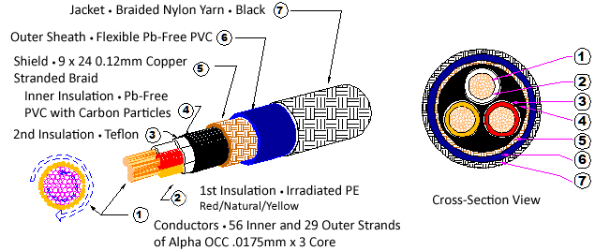

Awards
DeMag Wins CES Best of Innovations ’07 • e-TP609 Wins Absolute Sound Product of the Year Awards ’07 • G-320A-18 Power Cord Wins 6moons Blue Moon Award ’07 • Evolution Cables Wins Best of 2007 Awards Enjoy the Music • Reference III Cables Win Absolute Sound Editors’ Choice ‘07/’08 • AG-12 Phono Cable Wins the SoundStage Network’s Reviewers’ Choice Award ’08 • Ag-12 Phono Cable is Tone Audio’s Exceptional Value Award ’08 • Monza LP Stabilizer, Silver Arrows Phono Cable, La Source Headshell Extensions All Win Tone Audio’s Accessory Products of the Year • xv1.3 HDMI Cable Wins Positive Feedback’s Brutus Award ’08 • FI-50 Piezo Ceramic Series Connectors Win CES Best of Innovations ’09 • Monza LP Stabilizer Wins Positive Feedback’s Brutus Award ’09 • Select Series Fuses Win Positive Feedback’s Brutus Award ’09 • GT2 USB Cable is Playback Recommended ’09 • Torque Guard Speaker Binding Posts Innovations Honoree ‘11

Make A More Powerful Connection with Furutech!

FURUTECH CO., LTD. service@furutech.com

