

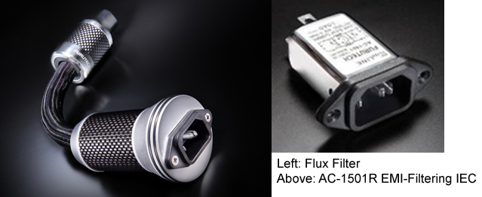

Furutech Flux-50 Inline AC Power Filter
Flux… The Most Revealing Cable Series Ever from Furutech

Furutech Co., Ltd., manufacturer of ultra refined analog, digital, video cable and accessories, reveals their top-of-the-line Flux-50 Inline AC Power Filter. The Flux series are, by far, the most revealing cable Furutech has ever made, designed to work best in an all-Flux systems including Lineflux, Speakerflux, Powerflux AC cords along with the Daytona 303 for active and passive AC filtering and power distribution. The Flux-50 is designed to be used in conjunction with single, sensitive components within such a system, such as phono stages and preamplifiers.

The Body Electric
The audio you hear from your audio system is essentially the incoming electricity itself, and the violent storms riding the AC line and its ground is extremely detrimental to the performance of your components.

The Flux-50 is a sophisticated, luxuriously made and finished inline power filtering unit that eliminates many common problems caused by contaminated electrical power lines. It protects against distortion caused by ground noise, voltage spikes and sags, high frequency power supply noise from other components in the system, plus high frequency digital noise from processors and digital interconnects.

You’re never alone when you take your listening seat; the residential AC supply is shared with other apartments, homes, and businesses on the same utility transformer explaining why many enthusiasts notice their systems perform to a higher standard late at night and weekends.

The Flux-50 features the Innovations Award winning FI-50 power connector. They combine two “active” materials: Nano-sized ceramic particles and powdered carbon. Nylon and fiberglass are incorporated as well forming an extremely effective, mechanically and electrically nonresonant connector body that may just be the most sophisticated in the world. And it incorporates the AC-1501R EMI-filtering IEC connector.

The Flux-50 Inline AC Filter lowers noise on every component on which it’s used resulting in very natural and extremely fine resolution down and through the utterly silent noise floor. It improves soundstaging and image palpability and creates sweet and incisive highs, an engaging, textured midrange tight and controlled bass, plus you’ll notice power and dynamics to spare.

Features
- Fitted with Furutech’s top-of-the-line Piezo Ceramic rhodium-plated α (Alpha) nonmagnetic FI-50R connector
- AC-1501R EMI-filtering IEC, rhodium-plated α (Alpha) nonmagnetic copper alloy conductors
- AC-1501R EMI filter features a parallel circuit with in-line coil and condenser, reducing noise at 1MHz by 10dB and at 10MHz by more than 30dB
- Floating Field Damper (Earth/Ground Jumper System) US Patent No.: 6,669,491
- Patent-pending metal cable clamp improves grip and reduces mechanically and electrically induced distortion
- α (Alpha) conductor shield for protection against radiated noise
- RoHS-compliant flexible PVC sheath improves vibration isolation
- Special high-grade PE Insulation contributes to reduced capacitance
- Incorporating Furutech’s special passive GC-303 EMI filtering material
- Filter held in housing with resonance damping Piezo epoxy

Frequency (MHz)

Filter Frequency Characteristics

Common mode

Normal mode

Resonance Damping Test: Shock applied to test points measured with a resonance sensor.
Flux-50 Filter-fitted cable:
Impact Point
Impact Point
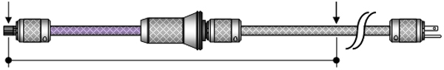

Cable without Flux-50 Filter
Impact Point
Impact Point
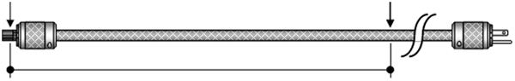

Flux-50 Filter Resonance Damping Effect

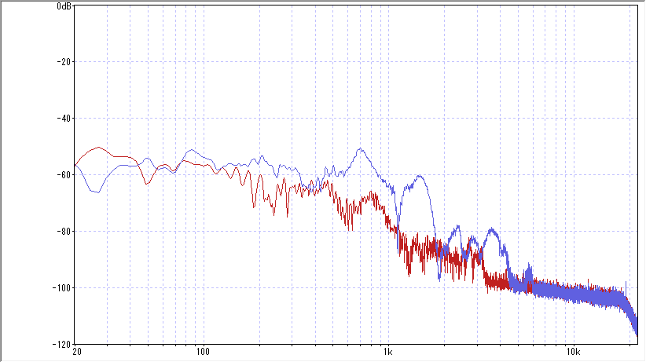
Measured Flux-50 Filter Resonance Damping Effect
With Flux-50 Filter (Red)

Without Flux-50 Filter (Blue)
Without Flux-50 Filter (Blue Line)

Results clearly show the Flux-50 Filter reducing reduces noise, oscillation and resonance in the cable by a factor of 10, resulting in very natural and extremely fine resolution down and through the utterly silent noise floor.

Cable Specifications:
- 68-strand α (Alpha) OCC conductor 0.127mm x 7 x 3 cores, 2.8mm diameter
- Inner Sheath: RoHS-compliant flexible PVC incorporating carbon powder
- Insulation: Special PE (Red/Natural/Yellow) 5.4mm diameter
- Sheath: RoHS-compliant flexible PVC (Purple/Red) 16.5mm diameter
- Shield: 0.12mm diameter α (Alpha) Conductor wire braid
- Jacket: Nylon braid approx. diameter 17.5mm
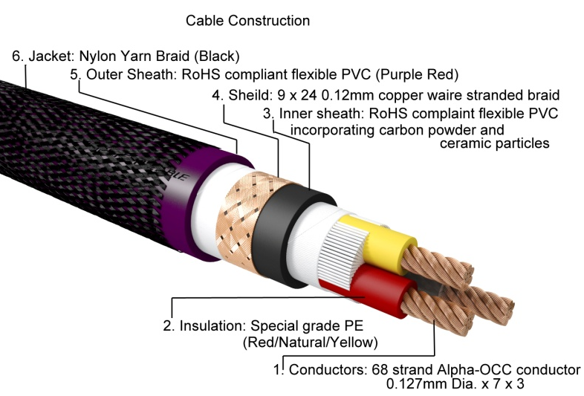
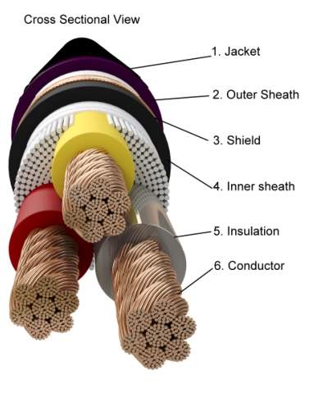

α (Alpha) Conductors are comprised of fine OCC wire twisted around μ–conductor strands and treated with Furutech’s Alpha Cryogenic and Demagnetizing Process

Click on links for information on the rest of the revealing Flux series. See link at end for photos.
Lineflux • Speakerflux • Jumperflux • Powerflux • Flux-50 • Daytona 303

About Furutech
Furutech makes a wide variety of high performance 15A and 20A A/V cable and power connectors and parts, as well as distribution/filtering products including the 120Hz standard xv1.3 HDMI cable, GT2 USB 2.0 and GT3 USB 3.0 cables, Ag-12 Silver Tonearm Cable, The Silver Arrows Tonearm Cable, La Source Headshell Wires, Monza LP Stabilizer Weight, the new Lineflux and Evolution II series, Pure Power 6, e-TP4+4, e-TP609, e-TP615 and e-TP60 Power Distributors, and e-TP80 Power Filters, deMag Disc and Cable Demagnetizer, PC-2 Disc Pure Cleaner, and their own very special NANO Liquid Contact Enhancer, plus even more fine cable and OEM products.

Awards
DeMag Wins CES Best of Innovations ’07 • e-TP609 Wins Absolute Sound Product of the Year Awards ’07 • G-302A-18 Power Cord Wins 6moons Blue Moon Award ’07 • Evolution Cables Wins Best of 2007 Awards Enjoy the Music • Reference III Cables Win Absolute Sound Editors’ Choice ‘07/’08 • AG-12 Phono Cable Wins the SoundStage Network’s Reviewers’ Choice Award ’08 • Ag-12 Phono Cable is Tone Audio’s Exceptional Value Award ’08 • Monza LP Stabilizer, Silver Arrows Phono Cable, La Source Headshell Extensions All Win Tone Audio’s Accessory Products of the Year • xv1.3 HDMI Cable Wins Positive Feedback’s Brutus Award ’08 • FI-50 Piezo Ceramic Series Connectors Win CES Best of Innovations ’09 • Monza LP Stabilizer Wins Positive Feedback’s Brutus Award ’09 • Select Series Fuses Win Positive Feedback’s Brutus Award ’09 • GT2 USB Cable is Playback Recommended ’09 • Torque Guard Speaker Binding Posts Innovations Honoree ‘10

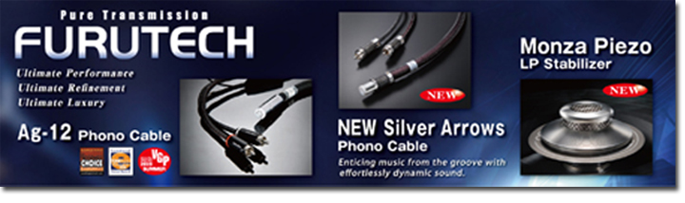

Make A More Powerful Connection with Furutech!
FURUTECH CO., LTD. service@furutech.com

Press • Info • Review • Images

Scull Communications • 212.807.0519

jscull@scullcommunications.com • www.scullcommunications.com

www.scullcommunications.com/pressresources.html

