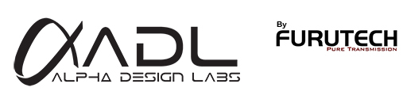
ADL (Alpha Design Labs) by Furutech GT40 24/96 USB DAC
Includes MM/MC Phono Stage… Records Vinyl and Other Analog Sources

Tokyo, Japan • Furutech Co., Ltd., manufacturer of analog and digital audio and video cable plus a wide range of accessories, debuts ADL (Alpha Design Labs), quality products built to Furutech’s Pure Transmission standards at surprisingly affordable prices.

The ADL GT40 24/96 USB DAC/Analog Recorder
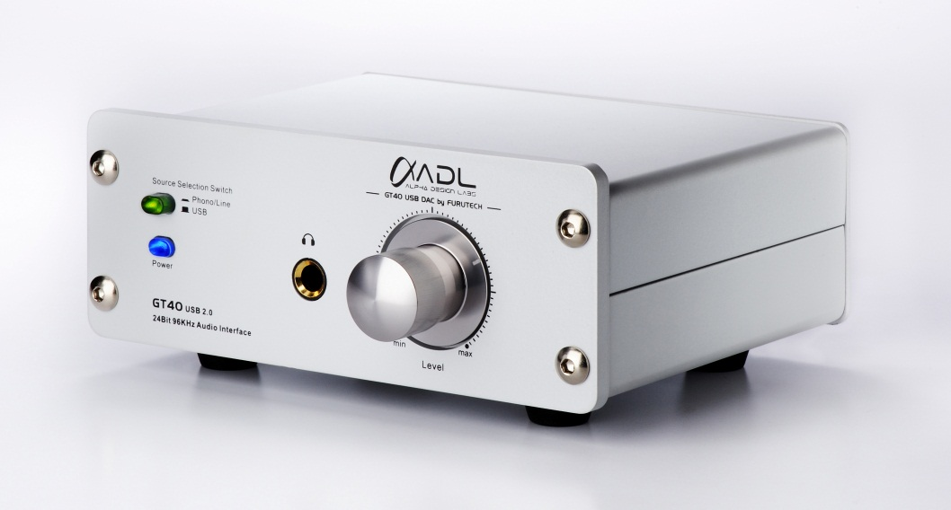
The designed in-house GT40 – stylish and compact – self-installs and dramatically improves computer-based audio from speakers and headphones. It’s designed for those with growing music collections on their computer hard drives that want (need!) high performance playback plus an easy way to archive LPs or other analog sources, a first in its product class.

The GT40 records at 16/44.1 or 24/96 using bidirectional USB and switchable Line or MM/MC Phono Stage inputs, plus it features L/R analog outputs, a separate headphone amplifier, gold-plated Teflon-insulated RCA jacks mounted in a high-quality aluminum chassis with a beautifully machined volume knob. CD Redbook 16/44.1 and especially 24/96 files reveal a vivid, captivating sound unheard of at this price… wired with Furutech’s Formula 2 USB cable of course!

GT40 Sound
The GT40 brings High End sound to your system in the following way: Recall any visit to a fellow audio enthusiast’s home. As music plays you can immediately hear if the sound “sets up” in an audiophile way: A sense of spaciousness, imaging, out-of-the-speaker sound, open highs and an inviting midrange over tight bass. The ADL GT40 brings Furutech’s signature sound of smooth, wideband, detailed clarity to desktop systems, especially with high resolution files, but 16/44.1 also sounds much improved. Your first impression will be that you’ve never experienced compute files sound so open!

GT40 Power Train
The heavily-shielded audiophile-grade GT40 features a trusted low-latency USB 2.0 ASIO audio driver that plays and records up to 96kHz. It’s completely plug-and-play; the operating system installs the GT40 as soon as the USB connection is made. While completely-USB powered devices might be convenient they simply don’t develop the power required for high-resolution playback, so the GT40 sports an external supply to remedy the issue.

At just under six inches wide and two-and-a-quarter high the GT40 USB DAC/Analog Recorder is easy to place and enjoy.

Drive Your Computer Music System to First In Class!

GT40 USB DAC Specifications
Connectivity | USB B Connector  Analog input/output on RCAs
USB Playback Resolution | 24-bits / 96kHz
USB Recording Resolution | 32kHz / 44.1kHz / 48kHz / 96kHz
Frequency response | 20Hz ~ 20kHz (40Hz: +0.5 dB, 15kHz: -0.5dB)
S/N ratio | -90dB (A-weighted)
Line Output Level | 1V RMS
Line Input Level | MC 0.4mV / MM 5mV / Line 1V
Phono Input Impedance | 47kOhms MM/MC
MC input to LINE output | 62.5dB@1k Hz plus 6dB Line level gain
MM input to LINE output | 48.5dB@1k Hz plus 6dB Line level gain
Maximum input level MC | 0.4mV RMS
Maximum input level MM | 5.0mV RMS
Maximum input level Line | 1V RMS @ 1K Hz
Recommended headphones impedance | 16 to 300 ohm
Maximum headphone power | 80mW / 32Ω
Power | External AC Adaptor
Dimensions | 150mm/5.9” (W) x 111mm/4.4” (D) x 57mm/2.25” (H)
Weight: | 785g / 1.5lb

About Alpha Design Labs
Furutech is justifiably proud of its reputation for engineering, build quality and performance. ADL was created by Furutech to imbue its Pure Transmission Technology into carefully engineered innovative designs that everyone can afford for creating high-level computer-based sound. ADL components are made with the same dedication to total resonance control and refinement as all of Furutech’s many cables and accessories.

About Furutech
Furutech makes a wide variety of high performance 15A and 20A A/V cable and power connectors and parts, as well as distribution/filtering products including the 120Hz standard xv1.3 HDMI cable, GT2 USB 2.0 and GT3 USB 3.0 cables, Ag-12 Silver Tonearm Cable, The Silver Arrows Tonearm Cable, La Source Headshell Wires, Monza LP Stabilizer Weight, the new Lineflux and Evolution II series, Pure Power 6, e-TP4+4, e-TP609, e-TP615 and e-TP60 Power Distributors, and e-TP80 Power Filters, DeMag Disc and Cable Demagnetizer, PC-2 Disc Pure Cleaner, and their own very special NANO Liquid Contact Enhancer, plus even more fine cable and OEM products.

Awards
DeMag Wins CES Best of Innovations ’07 • e-TP609 Wins Absolute Sound Product of the Year Awards ’07 • G-320A-18 Power Cord Wins 6moons Blue Moon Award ’07 • Evolution Cables Wins Best of 2007 Awards Enjoy the Music • Reference III Cables Win Absolute Sound Editors’ Choice ‘07/’08 • AG-12 Phono Cable Wins the SoundStage Network’s Reviewers’ Choice Award ’08 • Ag-12 Phono Cable is Tone Audio’s Exceptional Value Award ’08 • Monza LP Stabilizer, Silver Arrows Phono Cable, La Source Headshell Extensions All Win Tone Audio’s Accessory Products of the Year • xv1.3 HDMI Cable Wins Positive Feedback’s Brutus Award ’08 • FI-50 Piezo Ceramic Series Connectors Win CES Best of Innovations ’09 • Monza LP Stabilizer Wins Positive Feedback’s Brutus Award ’09 • Select Series Fuses Win Positive Feedback’s Brutus Award ’09 • GT2 USB Cable is Playback Recommended ’09 • Torque Guard Speaker Binding Posts Innovations Honoree ’11 • ADL GT40 Wins Tone Audio’s Budget Digital Product of the Year Award ‘11

Alpha Design Labs • www.adl-av.com • service@adl-av.com

Info • Press • Images • Reviews
Jonathan Scull • Scull Communications • 212 807.0519
jscull@scullcommunications.com • www.scullcommunications.com www.scullcommunications.com/pressresources.html


