

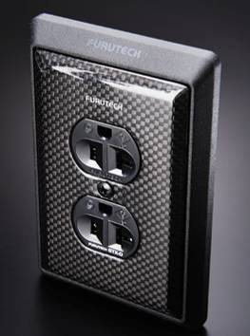
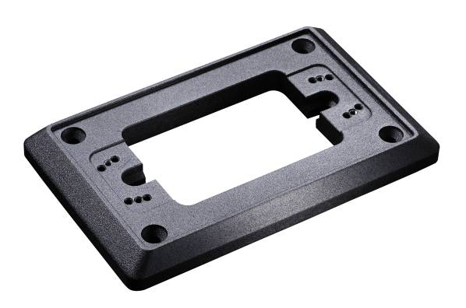

New at CES for 2011
GTX High Performance Wall Plate

Tokyo, Japan • January 1st, 2010 • Furutech Co., Ltd., manufacturer of analog and digital audio and video cable plus a wide range of accessories, unveils the GTX High Performance Wall Plate, show above left with 104-D cover and GTX-D receptacle.

Not Just Another Pretty Plate
Everything counts, and Furutech lavishes meticulous attention to build quality, a large part of the Pure Transmission engineering equation. The aluminum CNC-machined plate is luxuriously made and protects against RFI. It also features an effective nonresonant coating. Combined with GTX-D receptacles and the 1-4-D Carbon Fiber Cover, you’ll have Furutech Pure Transmission-level power transfer. Doesn’t your system deserve GTX power?

- Beautifully-crafted special-grade CNC-machined aluminum effectively shields against RFI (Radio Frequency Interference)
- Finished with extremely effective nonresonant coating
- Teflon damping foil and SUS receptacles, 4 fixing screw and 2 SUS plate-fixing screws
- Suitable for use with GTX-D or GTX-S receptacles and 104-D or 104-S carbon fiber-finished covers
- Plate thickness 13.0mm
- Dimensions: 135.0mm (l) x 86.0mm (w) x 13.0mm (h) -0/+0.3mm
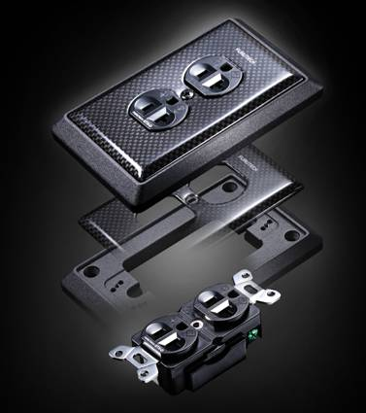

All Metal Parts Treated with Furutech’s α (Alpha) Super
Cryogenic and Demagnetizing Process

About Furutech
Furutech makes a wide variety of high performance 15A and 20A A/V cable and power connectors and parts, as well as distribution/filtering products including the 120Hz standard xv1.3 HDMI cable, GT2 USB 2.0 and GT3 USB 3.0 cables, Ag-12 Silver Tonearm Cable, The Silver Arrows Tonearm Cable, La Source Headshell Wires, Monza LP Stabilizer Weight, the new Lineflux and Evolution II series, Pure Power 6, e-TP4+4, e-TP609, e-TP615 and e-TP60 Power Distributors, and e-TP80 Power Filters, deMag Disc and Cable Demagnetizer, PC-2 Disc Pure Cleaner, and their own very special NANO Liquid Contact Enhancer, plus even more fine cable and OEM products.

Awards
DeMag Wins CES Best of Innovations ’07 • e-TP609 Wins Absolute Sound Product of the Year Awards ’07 • G-302A-18 Power Cord Wins 6moons Blue Moon Award ’07 • Evolution Cables Wins Best of 2007 Awards Enjoy the Music • Reference III Cables Win Absolute Sound Editors’ Choice ‘07/’08 • AG-12 Phono Cable Wins the SoundStage Network’s Reviewers’ Choice Award ’08 • Ag-12 Phono Cable is Tone Audio’s Exceptional Value Award ’08 • Monza LP Stabilizer, Silver Arrows Phono Cable, La Source Headshell Extensions All Win Tone Audio’s Accessory Products of the Year • xv1.3 HDMI Cable Wins Positive Feedback’s Brutus Award ’08 • FI-50 Piezo Ceramic Series Connectors Win CES Best of Innovations ’09 • Monza LP Stabilizer Wins Positive Feedback’s Brutus Award ’09 • Select Series Fuses Win Positive Feedback’s Brutus Award ’09 • GT2 USB Cable is Playback Recommended ’09 • Torque Guard Speaker Binding Posts Innovations Honoree ‘10

Make A More Powerful Connection with Furutech!

FURUTECH CO., LTD. • service@furutech.com

Press • Info • Review • Images
Scull Communications • 212.807.0519
jscull@scullcommunications.com • www.scullcommunications.com www.scullcommunications.com/pressresources.html

