

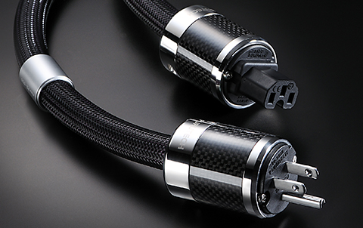
Powerflux Piezo AC Cords
With Innovations Award Winning FI-50 Piezo Ceramic Connectors

Tokyo, Japan • Furutech Co. Ltd., manufacturer of ultra refined analog, digital, video cable and accessories, reveals the Powerflux Piezo Electric AC cord. They are, by far, the most revealing power cords Furutech has ever made, designed to work best in an all-Flux systems including Speakerflux, Lineflux interconnects, Flux Jumpers if required along with the Flux-50 Inline AC Filter and Daytona 303 for active and passive AC filtering and power distribution.

AC Power Is the Foundation
The AC supply is directly in the signal path. As amplifiers transfer energy to speakers it draws down storage capacitors by exactly the same amount. The capacitors try to keep fully charged by drawing energy from rectifiers that turn the AC into DC from the transformer that draws power through the wall. Ultimately everything you see, hear and experience is the AC that must be identical to let’s say an amplifier’s output, and that AC travels through the power cord! That’s why they’re as important as any cable in a system because they carry the same signal. Furutech has received enthusiastic reports of significant improvements with every type of audio, video and display device.

Cable Essentials
Powerflux conductors are 68-strand α (Alpha) OCC conductor with special-grade PE insulation/dielectric. (α Alpha conductors are comprised of fine OCC wire treated with Furutech’s Alpha Cryogenic and Demagnetizing process.) The dielectric is surrounded by an inner sheath of RoHS-compliant PVC incorporating a fine carbon powder that enhances damping, and that in turn is covered by a full Alpha conductor wire braid shield. Another flexible PVC outer sheath and a Nylon yarn braid jacket finish the job.

Piezo Ceramic Connectors
The extraordinary FI-50 series connectors are standard equipment on the Powerflux. Furutech’s beautifully-finished FI-50R IEC and FI-50R Piezo Ceramic series connector housings are made of multi-layer carbon fiber encased in a damping and insulating acetal copolymer, surrounded by nonmagnetic stainless steel bands.

The Innovation Awarding winning connector bodies combine two “active” materials: Nano-sized ceramic particles mixed in with powdered carbon. Nylon and fiberglass are incorporated as well forming an extremely effective, mechanically and electrically nonresonant connector body that may just be the most sophisticated in the world.
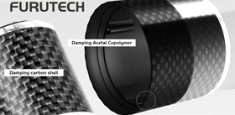
Meticulous engineering and careful audition of various suitable materials results in the superb overall balance of qualities that Furutech is known for that allows you to feel experience and communicate with music. The results are extremely fine resolution down and through the very low noise floor, improved soundstaging and image palpability, a musical, attractive, “round” midrange, tight and controlled bass, plus power and dynamics to spare to set your music on fire!

Construction and Materials
- 68-strand α (Alpha) OCC conductor・0.127mm x 7 x 3 cores, 2.8mm diameter
- Inner Sheath: RoHS-compliant flexible PVC incorporating carbon powder
- Insulation: Special PE (Red/Natural/Yellow) 5.4mm diameter
- Sheath: RoHS-compliant flexible PVC (Purple red) 16.5mm diameter
- Shield: 0.12mm diameter α (Alpha) Conductor wire braid
- Jacket: Nylon yarn braid approx. diameter 17.5mm

Features
- Fitted with Furutech’s top-of-the-line FI-50 Piezo Ceramic series connectors
- Furutech’s beautifully-finished FI-50R IEC and FI-50R Piezo Ceramic series connector housings are layered carbon fiber in a damping and insulating acetal copolymer surrounded by nonmagnetic stainless steel. The European version features FI-E50R Schuko
- Connector bodies combine two “active” materials: Nano-sized ceramic particles and powdered carbon which are also mixed with nylon and fiberglass forming an extremely effective, mechanically and electrically nonresonant connector body that may be the most sophisticated in the world
- Piezo Ceramic series connectors feature α (Alpha) Pure Copper conductors equipped with Furutech’s advanced Flux Damper Earth/Ground Jumper System (US Patent No.: 6,669,491)
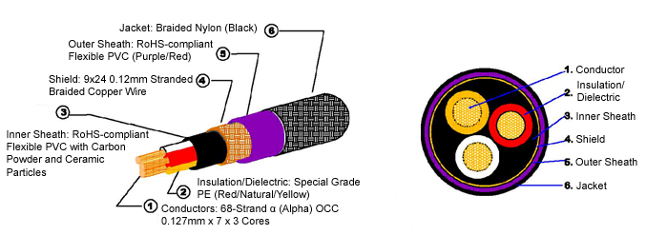
- Patent-pending metal cable clamps improves grip and reduces mechanically- and electrically-induced distortion plus patent-pending specially-engineered pressure plates
- Cable features a full α (Alpha) conductor shield to protect against radiated noise
- RoHS-compliant flexible PVC sheaths enhance vibration control
- Special high-grade PE insulation/dielectric reduces capacitance
α (Alpha) Conductors are comprised of fine OCC wires twisted around μ–conductor strands and treated with Furutech’s Alpha Cryogenic and Demagnetizing Process

Electrical Properties |  | Test Method
Max. Conductor Resistance | 4.5 Ω／km | JISC3005 6 20ºC
Min. Insulation Resistance | 2500 MΩ-km | JISC3005 9.1 20ºC
Dielectric Strength | AC.3000 V／1 min. | JISC3005 8

Click on links for information on the rest of the revealing Flux series. See link at end for photos.
Lineflux • Speakerflux • Jumperflux • Powerflux • Flux-50 • Daytona 303

About Furutech
Furutech makes a wide variety of high performance 15A and 20A A/V cable and power connectors and parts, as well as distribution/filtering products including the 120Hz standard xv1.3 HDMI cable, GT2 USB 2.0 and GT3 USB 3.0 cables, Ag-12 Silver Tonearm Cable, The Silver Arrows Tonearm Cable, La Source Headshell Wires, Monza LP Stabilizer Weight, the new Lineflux and Evolution II series, Pure Power 6, e-TP4+4, e-TP609, e-TP615 and e-TP60 Power Distributors, and e-TP80 Power Filters, deMag Disc and Cable Demagnetizer, PC-2 Disc Pure Cleaner, and their own very special NANO Liquid Contact Enhancer, plus even more fine cable and OEM products.

Awards
DeMag Wins CES Best of Innovations ’07 • e-TP609 Wins Absolute Sound Product of the Year Awards ’07 • G-302A-18 Power Cord Wins 6moons Blue Moon Award ’07 • Evolution Cables Wins Best of 2007 Awards Enjoy the Music • Reference III Cables Win Absolute Sound Editors’ Choice ‘07/’08 • AG-12 Phono Cable Wins the SoundStage Network’s Reviewers’ Choice Award ’08 • Ag-12 Phono Cable is Tone Audio’s Exceptional Value Award ’08 • Monza LP Stabilizer, Silver Arrows Phono Cable, La Source Headshell Extensions All Win Tone Audio’s Accessory Products of the Year • xv1.3 HDMI Cable Wins Positive Feedback’s Brutus Award ’08 • FI-50 Piezo Ceramic Series Connectors Win CES Best of Innovations ’09 • Monza LP Stabilizer Wins Positive Feedback’s Brutus Award ’09 • Select Series Fuses Win Positive Feedback’s Brutus Award ’09 • GT2 USB Cable is Playback Recommended ’09 • Torque Guard Speaker Binding Posts Innovations Honoree ‘10

Make a More Powerful Connection with Furutech!
FURUTECH CO., LTD • service@furutech.com • www.furutech.com

Press • Info • Review • Images

Scull Communications • 212.807.0519

jscull@scullcommunications.com • www.scullcommunications.com

www.scullcommunications.com/pressresources.html

