
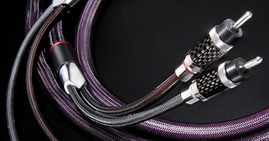

Furutech Speakerflux Cable
Is Your System Up To It?

Furutech Co., Ltd., manufacturer of ultra refined analog, digital, video cable and accessories, debuts their top-of-the-line Speakerflux cables terminated with high quality bananas or spades. The Flux series are, by far, the most revealing cable Furutech has ever made, designed to work best in an all-Flux systems including Lineflux, Flux Jumpers if required, Powerflux AC cords along with the Flux-50 Inline AC Filter and the Daytona 303 for active and passive AC filtering and power distribution.

The Effective Diameter of Your Music
The link between speakers and amplifiers is one of the most critical in a system. Speaker cables carry high current and require low resistive loss to avoid turning part of the signal energy into heat; high performance construction techniques call for large cable diameters or bundles of smaller conductors for an effective large diameter. Low resistance also keeps an amplifier’s damping factor high thus avoiding uncontrolled driver movements.

Furutech specifies α (Alpha) OCC Pure Transmission conductors terminated with beautifully-engineered high-performance rhodium-plated nonmagnetic pure-copper spade connectors. Rhodium-plated banana connectors are also available on request. The substantially-built extremely nonresonant connector bodies are finished in six layers of carbon fiber with stainless steel. The dielectric/insulation is high-grade PE reducing capacitance and improving mechanical damping for greater resolution, clarity and dynamics, plus an ultra-quiet soundstage in which music develops more fully without artificial upper-frequency “presence region” glare.

The sound is sensationally transparent, dynamic and revealing. But every sword has a double edge, and if there are flaws in the rest of your system, Flux will only be too glad to make that readily apparent. Paired with smooth, extreme-resolution components the sound can be sonic bliss. In the context of a somewhat more forward, less-resolving system, Furutech offers its Reference III and Evolution II series cables which are slightly more forgiving of flaws, especially in the upper frequencies.

Click on links below for information on the rest of the revealing Flux series. See link at end for photos.
Lineflux • Speakerflux • Jumperflux • Powerflux • Flux-50 • Daytona 303

Available Now in 2m and 3m Lengths

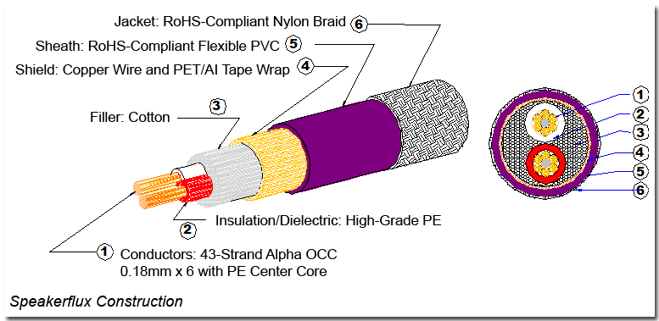

Features
- α (Alpha) OCC Pure Transmission Conductors
- Beautifully-engineered high-performance rhodium-plated nonmagnetic pure copper spades Type CF-201R
- Nonmagnetic rhodium-plated banana connectors by request Type CF-202R
- Dielectric/insulation: High grade PE reduces capacitance for improved vibration damping
- Results in greater resolution, clarity, powerful dynamics, and an ultra-quiet soundstage in which music develops more fully without artificial upper-frequency “presence region” glare.

α (Alpha) Conductors are comprised of fine OCC wire twisted around μ–conductor strands and treated with Furutech’s Alpha Cryogenic and Demagnetizing Process

Links

About Furutech
Furutech makes a wide variety of high performance 15A and 20A A/V cable and power connectors and parts, as well as distribution/filtering products including the 120Hz standard xv1.3 HDMI cable, GT2 USB 2.0 and GT3 USB 3.0 cables, Ag-12 Silver Tonearm Cable, The Silver Arrows Tonearm Cable, La Source Headshell Wires, Monza LP Stabilizer Weight, the new Lineflux and Evolution II series, Pure Power 6, e-TP4+4, e-TP609, e-TP615 and e-TP60 Power Distributors, and e-TP80 Power Filters, deMag Disc and Cable Demagnetizer, PC-2 Disc Pure Cleaner, and their own very special NANO Liquid Contact Enhancer, plus even more fine cable and OEM products.

Awards
DeMag Wins CES Best of Innovations ’07 • e-TP609 Wins Absolute Sound Product of the Year Awards ’07 • G-302A-18 Power Cord Wins 6moons Blue Moon Award ’07 • Evolution Cables Wins Best of 2007 Awards Enjoy the Music • Reference III Cables Win Absolute Sound Editors’ Choice ‘07/’08 • AG-12 Phono Cable Wins the SoundStage Network’s Reviewers’ Choice Award ’08 • Ag-12 Phono Cable is Tone Audio’s Exceptional Value Award ’08 • Monza LP Stabilizer, Silver Arrows Phono Cable, La Source Headshell Extensions All Win Tone Audio’s Accessory Products of the Year • xv1.3 HDMI Cable Wins Positive Feedback’s Brutus Award ’08 • FI-50 Piezo Ceramic Series Connectors Win CES Best of Innovations ’09 • Monza LP Stabilizer Wins Positive Feedback’s Brutus Award ’09 • Select Series Fuses Win Positive Feedback’s Brutus Award ’09 • GT2 USB Cable is Playback Recommended ’09 • Torque Guard Speaker Binding Posts Innovations Honoree ‘10

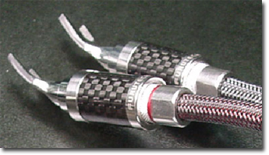

Make a More Powerful Connection with Furutech!
FURUTECH CO., LTD service@furutech.com • www.furutech.com



Press • Info • Review • Images
Scull Communications • 212.807.0519
jscull@scullcommunications.com • www.scullcommunications.com
www.scullcommunications.com/pressresources.html

